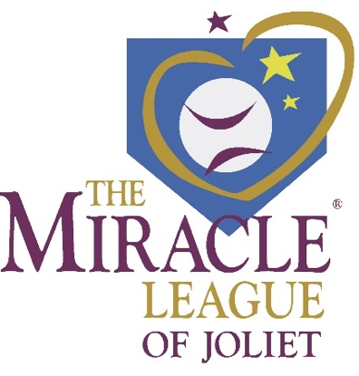
2017 Seasonal Sponsorship Opportunities

Please return this form completed in the included envelope with your choice of sponsorship participation. Checks made payable to The Miracle League of Joliet.

All sponsors will receive recognition weekly during 12 our games

 TRIPLE PLAY: $5,000
Company Name or Logo on Dugout Sponsorship of a Miracle League Team
Company Name on Player Jerseys Company Name and Logo on Outfield Fence - 4x8 sign

 2nd INNING STRETCH: $2,000
Company Name or Logo on Bleachers Sponsorship of a Miracle League Team
Company Name on Player Jerseys Company Name and Logo on Outfield Fence - 4x8 sign

 TEAM SPONSOR: $1,000
Sponsorship of a Miracle League Team Company Name on Team Jersey
Company Name and Logo on Outfield Fence - 4x8 sign

 LEAGUE SPONSOR: $500
Company Name and Logo on Outfield Fence - 4x8 sign

 SLUGGER SPONSOR: $250
Company Name and Logo on Outfield Fence - 3x5 sign

 PLAYER SPONSOR: $100
Provides registration fee for a player who cannot otherwise pay

SPONSOR INFORMATION

Name to Appear on Signage: _______________________________________________________________
Contact Name: ________________________________ E-mail: ___________________________________
Address: ________________________________________________________________________________
Phone Number: ____________________________________

Please email your logo to Nick Ferro: nferro@miracleleagueofjoliet.com

PLEASE NOTE: Triple Play, 2ND Inning Stretch and Team Sponsorships must be paid in full by April 5th in order to have company name on uniforms.

